THE HEALTHCARE SYSTEM AND
THE HIDDEN TRAPS OF ITS LOGISTICS

Larisa Mihoreanu¹ Carmen Costea² Alexandru Stefanescu³
¹Bucharest University of Economic Studies mihoreanu@spiruharet.ro
²Spiru Haret University Bucharest cecostea@yahoo.com
³Bucharest University of Economic Studies dr.alexstefanescu@yahoo.com

Abstract: The analysis of the society development is more complex than one might think at first glance. So is the market. There are sides and activities not easy to see and one needs high capabilities and strength to look beyond the appearances and see what’s not visible.
The most dangerous games happen inside the crossing boarder sectors that no men land between legal and black activities; that is a very vivid area where actions and profits are higher than ever can imagine. This side of the economy has its tentacles piercing the legal boarder of the sound economy and functions through movements that effect all sectors and activities pushing to get huge black profits.
Romanian health sector makes no exception. The wish to get getting higher and higher profits doesn’t go with performing and satisfactory management when the corporate liaisons are oriented more on discussions and less on integrative quality and satisfaction of people concerned; thus the so called guys in white coats are necessarily oriented to another sort of motivation – linked to networked process of getting black money and laundering it through the backing support of the informal more than legal procedures.
The loss is always paid by individuals and community as: fewer funds from taxes, stratified salaries caused subjective application of norms and procedures, decreased labour quality, inappropriate economic behaviour, losses in the robustness of the future generations. Through such channels, the informal economy last running building up a strong logistic that develops parallel activities, utterly designed to respect specific customs based on gestural understanding and communication that encourage the unfairness, the aggressiveness in competition and hot money/short run investments.
This paper intends to catch some of the general aspects of what black and informal economy can carry out, through procedures that use the imperfect legal methodology decision and its implementation into informal possibility to fraud both the public funds and peoples savings.
The paper touches also the public consequences of the undeclared work of employees of public and private sectors emphasising also the need to identifying some specific roles to play in the future by the services business planning, the law application and the policy of autonomy to help the medical market blossom vigorously.
In conclusion, we sustain that the fair action is not an alternative conception of developing, in the fashion neither of human evolution nor of need-based growth. There is a higher need to model individual awareness and motivation in the direction of increasing the self-responsibility for building a better environment based on a proactive personal development, from within and connected to the outer world.

Keywords: Hidden economy; Medical care hidden logistics; Psychological Health
JEL Classification: I 100, I 130, O1, O17, P37, P39
Argument
During the last decades, the dynamic of modern society was governed by a double movement: a continuously market expansion doubled by a countermovement blowing up into determined directions. Considered useful for its protection, such a countermovement became incompatible with the self-regulation and the market system itself. Developed in leaps and bounds, engulfing space and time, the system outlined also a dynamic terra incognita hitherto. In self-defence, the society faced the change reaction against profit dislocation. The act of black money creation continues interference inside both market and society mechanism. The tipping point is that, no matter what it is used for - goods, money or replacements, their supply and demand contribute to market regulation by all commodities and services. For business purposes or explanations, in similar situations, the self-regulating market threatens everything for similar reasons. In this respect, legislating and social jurisprudence are required to protect producers, providers and beneficiary. As a main paradox, the societal management have been highly needed to shelter the production from devastating effects over self-regulated market. The same happens in the services area or what we can call here the health and care industry.

From economic evolution to societal make-ups
More and more economic proofs are brought to sustain the idea that market ceased to be the panacea regulating all problems: rational distribution of resources, robust development, and eradication of poverty. The economic crisis always returns, the overseas surpluses gradually made room for the European deficits of payment balance undermining the trust in all currencies. Many third world countries sunk into the vicious circle of poverty and sickness in debt for paying old debts and selling their raw materials or mono-products at very low prices. With this, a new economic order began, where the speculations of productive investments started to count on the virtual side of economies, the flexibility of new technologies, intending to rapidly unblock the productive activities, accepting the future options of sales while searching for high profits. The result meant ending up back in situations, where floating capital, largely disconnected from productive capital globalized national or regional economies into a big mix.
A new problem was to face: the increasing influence of the public sectors with its negative effects at national and regional level while the private capitals were oriented to underground investment bringing hot money. The general approach of open market implementation required new basis and principles, a last change in mentality, ideas and economic patterns, as a pathfinder towards the entrepreneurial spirit development. The last twenty-six years down the path toward capitalism marked off the life quality by unemployment, poverty, sickness, organized crime rate increment with no end expectations [Fisher, 1993].
The light of regulation has not entirely been off in that current state of disorder. It is still there, on the European side, as strong as in the USA or anywhere else as the world economic games brought partial good consequences, only for very few parties involved.
The today providential state crisis obviously sustains the necessity of overthrowing the tendencies. When this kind of State was thought to introduce a non-capitalistic set of principles (social protection, public services production as opposed to the production of goods and true values) everlasting economic and social life, it became clear that the logic behind capitalist accumulation would come back to the social protection problems and discussions. It also determined the subordination of public services to the dynamics of net added value and the issue of public services profitability. The attempts to diminish the public drawing of funds have had disappointing results. This kind of highly costly social regulation was due to support the unemployed during social reconversion stages or overlooking those who benefit from social assistance. With the cost of these regulations serving as an alibi for attacking social protection, pension systems, and all public policies, the vicious circle is nearby.
The capitalistic development issues a poorer society with highly polarized population caused by the new changes in education, labour reform, lack of social motivation of work. Looking for the most convenient path for growth, it deepens poverty by diminishing the means of the public power and its capacities. It is still told that, by its virtues, the capitalist economy is able to provide to the Society the necessary coherence, under the prices and decisions game and consumers choice. Targeting investments towards the necessary and the profit of society, the equilibrium could be touched within expected adaptation as a proper functioning exigency of the adopted mechanism in all sectors of activity.
Statistics are here to sustain the bad side of current changes and the market collapse. In the medical sector, Romania takes the first before the last position inside the European Index of Medical Systems, with only 452 points of 1000; she takes the 35th position slightly before Bosnia and Herzegovina. While referring to the medical treatment results, Romania definitely gets the final position in Europe, near Serbia.in opposition, the search of the corruption statistics show better placement for countries like ours.

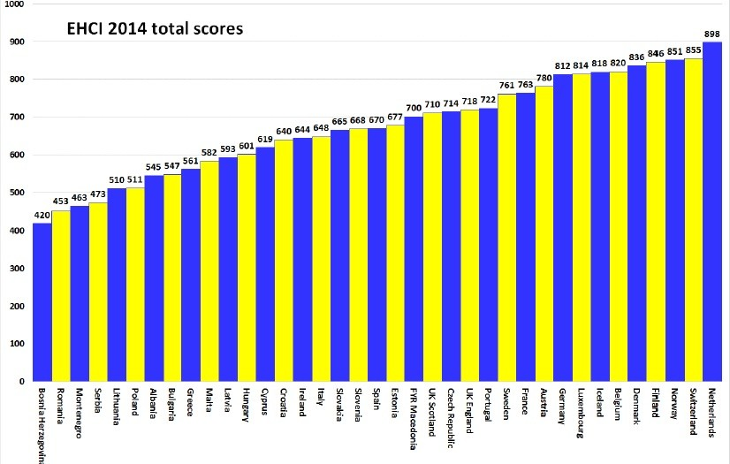
Charter 1. EHCI Ranking 2014

According to dr. Arne Björnberg [EHCI, 2014], Romania and Serbia are among the countries in red for all the eight indicators of treatment results: the rate of cardiovascular deceases, the decrease of deceases by cerebral vascular accident, children mortality, the ratio of surviving in cancer, preventable Years of Life Lost, infections with golden staphylococci methicillin resistant, the abortion rate, and depression. In fact, the sharpest indicator – the infantile mortality is almost 10 for 1000. The European Commission recommendation is in such cases, the reduction of the medical assistance in hospitals and the switch toward ambulatory care inside small, modern clinics to diminish the weight on the public financial effort inside the medical and health care systems (reduction of the medical price and the improvement of the medical treatment and services. To avoid the medical collapse, Romania needs the re-establish the fundamental criteria and services granted to the population such as: maternal care, general medicine via general practitioners’ network, elimination of corruption and the medical specialists drain to the western countries.
The HCP Report analyses 48 indicators grouped in six categories: consumers’ rights and access to information, the open access and the waiting delay, the treatment results, the medical services provided and their extent, the prevention services and the pharmaceuticals, as follows:

Table 1. Position of Romania by European general scoring

 | Top EU scores | Romania
Patients’ rights & information | 146 | 83
Accessibility | 225 | 100
Outcomes | 240 | 83
Range and reach of services | 150 | 63
Prevention | 107 | 71
Pharmaceuticals | 86 | 52
Total score | 954 | 452
Position occupied in EU | 1 of 36 | 35/36
The top position is occupied by Netherlands (898 points), followed by Switzerland (855 points), Finland (846 points) and Denmark (836points), while the last one belongs to Bosnia Herzegovina. The situation is similar under the quasi-permanent effects of crisis. Under inseparable conditions of economic and social development, the solution to the inherent societal issues of a burden economy as ours must be able to provide a unitary vision, in high tune with contemporary realities and country specificity.
Such a vision requires coordination of the current state-of-art of economic with the social level of development and corresponding policies, a holistic and coherent concept, able to offer viable solutions related to: the grim social situation, caused by the complex hidden social problems accumulated over the years; the need for a real support to build a decent standard of living after their reconfiguration according the modern approaches and future general needs. As the local strategies and policies seem avoiding notions as correctness, honesty, and ethics that became rara avis characteristics, there is a hot demand for a dynamic integrated policy system, based on the severe acknowledgement of affairs stage today and offering intelligent solutions to the social issues, hence becoming a stimulating factor for economic development.
The social protection measures stem from manifesting a special concern for bridging the gaps of inequalities, ensuring economic and social reconciliation and giving each person a due place inside the society, understanding aspirations under a large social dialogue, promoting trust, faith and individuals esteem, confidence inside the community – until the establishment of a more just fiscal system, reconsidering and enhancing purchasing power, the right to have a home, enhancing trust in progress and, finally, enable all members of society participating as active economic agents to the building of resources that sustain the measures for robust evolution and international recognition.
As the credit is taken for the capitalist market heart, a special role has to be dedicated to it to providing it as a necessary development and achievement resource, as a whole. Only by creating appropriate conditions for all sort of legal entities to run their business, in parallel with the societal interests, companies and services providers will be able to meet and respect each other’s interest for the development sake. Otherwise the so called development will produce illegal results affecting the soft money acceleration and the economic disaster for the hidden economy benefit.

Relational misrepresentations between the real and hidden insights of medical market:
Sometimes, a huge part of the economic life is slipping away of the rule of law ending up in business that can bring money only in the pockets of a people, damaging the societal system as a whole. When the law is ignored, the dirty money drops to the surface laundering into informal ways. Similarly, hard money, originating from legal businesses can slip into the underground sector and get dirty by financing illicit actions, with the aim of obtaining larger profits in less time, which would be impossible to obtain in an economy without the forces of competition and without the support of facilities for consolidation and development.
Affected by the bad economic times, a good part of population bound its destiny to the parallel economy. Government tries to identify its force using alternative macro indicators’ scale: the consumption of energy. But this is not enough: this type of new open economy allows and generates supplementary earnings by breaking the law, avoiding paying fees and taxes, not declaring additional incomes, or using black money in a continuous laundry system. The black market scorings apply for currency, narcotic trafficking, work places, sold products, migration, and the informal way to provide services. A black, informal market exists and proliferates in the field of services as well in parallel with corresponding tax evasion.
Between the formal and informal economic sectors there are strong links and relations amplified by corruption. The spectrum is large: from raw materials withdrawn from public companies – most often financed by the state through non-performing credits – and used on the black market, to illegal transfers of currency, withdrawing from foreign markets in exchange for great fees, defying and breaking the laws of bank operations, through complex services provided illegally inside the public/private binome (according to the place, provider, founder). There is also a reversed flow: lots of the money originating in the informal economy resurfaces in legal economic circuits (building hospitals, acquisition and procurement, sponsoring medical care services, trading pharmaceuticals, VAT return).
Healthcare sector is similar to all the other fields of activity. To be recognised as profitable, it needs to bring together excellence in business and patients satisfaction. With the population increasing and the life expectancy longer, some changes are also required in the delivery of treatments administration. Therefore, a strong data warehouse is being used to predict epidemics, cure diseases, in addition to articulated public policies to improve quality of life and avoid preventable deaths. The drive now is to understand as much about a patient as possible, as early in their life as possible – hopefully picking up warning signs of serious illness at an early enough stage that treatment is far more simple (and less expensive) than if it had not been spotted until later.
The informal system is real too, it can be found with concrete results in the GDP – sometimes, with positive influences for the consumption development. However, this is only one side of the coin. The reversal, detrimental, is easily analysed and eventually overcome by initiating actions that would soften its negative effects. Throughout the transition to the market economy, the illegal practices of obtaining and legalizing some larger sums extended on the capital market, which put in danger, not only the market as an institution but also individuals and companies, by its artificial arrangements. A huge damage in products and market trust was done which was detrimental to the entire economic and social development.
Legalizing the incomes produced beyond the real economy, under the conditions of eluding viable legislation – an activity known as money laundering – has come to be very hot today, for many reasons: • the money laundering operations includes corrupted key specialists into the criminal organizations; • the weak response to investigating such operations within the systems, leading to business insolvency and bankruptcy; • the current legal framework is not able to prevent and provide solution to such phenomena (the use of healthcare cards’ system is a good example); • the frauds rates grow in parallel with the those from the insurance sector being networked to links generating the funds ‘recycling.
Another problem consists of quantifying the illegal incomes and relevant literature illustrates many ways in which traffickers facilitate the illegally funds flows towards the formal economy [Costea, 2000].
Sustainable development should aim for a long-term calendar, of which economic and social coordinates meld into integrated efficiency and performance. A successful scenario would ignore the incomplete economic statistical data, such as GDP and turn to the data, which expresses the true economic and social strength of each country. Beyond the evolution of the GDP and the demographic dimension of a country, an important concept should be the given societal satisfaction.
The global problems of mankind are already evidently identifiable – from the climate and natural resources, to the appalling inequity between privileged societies and undeveloped masses suffering in hunger, poverty and disease.
The time has come for advancing toward a civilization, culturing the awareness and self-engagement into successful action of satisfaction, eliminating the bureaucratic erosion”, and introducing the trust, reliability and consensus about solving any economic or social problem.
Value must become a measurement that is rightfully attributed, etiquette of morals and aesthetics and truth, which is characterized as a noun, depending of circumstances.
The growing dynamism of the work market and, implicitly, the rise of unemployment, together with the impoverishment of large categories of the population generate the danger that the system of state social insurance might lead to great deficits in the public budget.
For this reason, at a governmental level, it is on the one hand imposed to avoid over-soliciting the public budget by unjustifiable spending, quasi-automatic spending, and on the other hand, it is imposed that real possibilities be created to reorganize the institutions in the field of social security, with a greater autonomy and the power to consolidate their own financial capacities, by building a system of social protection of services very tightly correlated with the level of contributions.
In parallel, the state system of social security must help the poorest of the poor learning to survive. Simultaneously, social clusters of aid built as tampons between public and private entities, can mobilize the practical and conceptual know-how so necessary for restructuring.

Towards a sound development via a motivated spiritual acknowledgment
In order to achieve it, the general perspective on market behaviour must take a step forward. Therefore we bring into consideration the Capitalized and Returned Added Value (CRAV). We reconsider our initial proper indicator [Costea,2007] modified with José Luis Iribarren [2010] Customers’ Network Value Concept into a new way to capitalize and return added value[Costea,2006] to different sort of individuals, groups and society. With few words you may find below, replicated, the CRAV model, such as:
Individual Capitalized Value (ICV) attempts to capture the value provided to the society/company by individual skills and word-of-mouth activities. Such value is generated at individual and business level in the form of diminished promoting expenses due to the fact that individuals do their own promotion by deep motivation. With this approach, the purposeless driven individuals do have a value for other peoples’ goals and may be worth being marketed to. The challenge, however, is how to determine the states of their Societal Network states compute them into the models. Let’s take a quick look at some approaches for detecting and measuring Individual Network Value. CRAV model requires behaviour attributes relevant for prediction of customer’s value and of individuals’ value as well, in order to predict short-term individual behaviour: regency – period of time since last education skill or purpose taken; frequency – number of targets assumed; value contribution obtained, other policies.
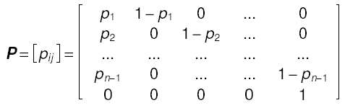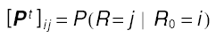
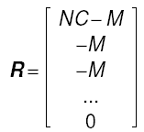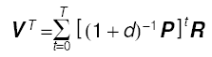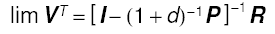
Where
P = Transition probabilities matrix
R = Recent flows vector
V = individual value vector
D = Financial discount rate/contribution rate
T = Total time steps
CRAV in the presence of WOM introduces the Contributors’ Network Value concept where
- Individual Value = Intrinsic Value + Network Value
- Intrinsic Value (CLV) based on probability of goals attained
- Network Value (NV) based on influence of others’ probabilities of objectives attained
- Ignoring Network Value can determine incorrect decisions, especially in a society/service delivery with strong network effects.
Add to an individual’s value the expected profit from any potential benefit towards other individuals ones may influence to act for, the individuals those may influence, and so on recursively. An individual’s network value depends not only on herself, but on her relationships and the configuration and state of the entire Social Network. We introduce WOM, CRAV Client Network Value concept where:
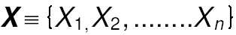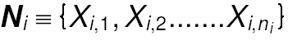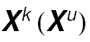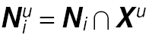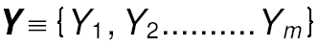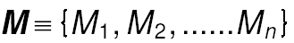
)
Set of patients with (un) known status
Neighbors: Patients/Providers
roviderssCustomers influence X_{i}
Set of providers with unknown status
Treatment attributes
Individual Mentoring
/Healing activities
(Boolean or continuous)
Calculating the Network Value: Modelling the Social Network as a Markov Random Field
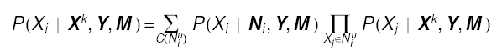
Under certain assumptions: 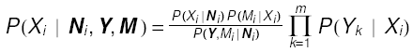
Network Value: Estimated Lift of Profit function of conditional probabilities of customer states
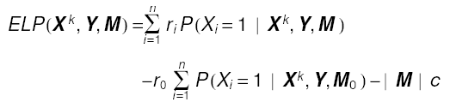
Where:
| M | = Number of 1’s in M
r_{i} = Revenue when marketing
r_{o} = Rev. without marketing
c = Cost of marketing
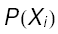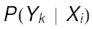
Must calculate the probabilities:
P ( Xi | Ni ) represents mechanism whereby people or prpoviders influence each other.
In order to determine the most appropriate substrate model network for simulating real life processes, it is possible to look situations simultaneously presenting all main characteristics of Social Networks. They are composed of many isolated clusters with small longest paths and whose cluster size and node degree distributions follow power laws. However the clusters form factor presents significant differences with the experimental findings and this, and other, aspects need to be investigated further.
This concept is followed by a set of principles to take into account when a transit is required to another stage of activity to a higher one, based on motivated awareness and responsibility acknowledged and assumed:
1. Drive ethically. A life and activity that are driven by pleasure can eliminate social stress and create images – the favourite subject of mass media.
3. Act with dynamism and social strength are not an allusion to aggression, but, more likely, an alternative, a way, an incentive to make an individual or an entity act or behave as the decider wants, after persuasion, incentive and following general norms. Force has become a myth, which fusions with the notion of aggressiveness or strength most of the time.
4. Be aware and engage in your management decision. This facilitates access to a good way of functioning, assures the best governing solution by reducing the obsessive struggle for power.
5. Wear the value of yourself and your decisions. The greatest damage brought to society because of wrong politics declining professionalism. The initiation for the inner growth of the drive for professionalism, correctness and excellence generate a responsible awareness.
6. Feel happy in a secure relationship with yourself and the community. In a political society, belonging to a party is what decides the occupation of key places in the economy, administration and leadership of public services. Politicianism is a trend encouraging low skills, corruption and bureaucracy. Any society vitally interested to promote interests of well-being, economic vigour and scientific innovation should avoid the wrong politicians. Such interests are long term education based as they should learn to manage covering the debate, solutions and the promotion of society’s real interests.
7. Develop the inner side of yourself. Individual and the Society are embracing concepts that can exist only together. The mankind fulfilment gets with the other species development, but it reaches its zenith inside the community offering its recognition and distinction.
8. Behave bravely polite and worthy of self-esteem or other people respect as the qualities are never overrated if are brought forth in the moment for enlightening, fulfilment, and creative completeness.
9. Staying always connected to individuals needs gives the limitless rights that people can enjoy in complete patterned freedom. Rights and duties are two sides of the same coin. Well, although they are yet another couple of inseparable opposites, the first have been kept, while the latter have been neglected or even forgotten. The lack of responsibility stands at the heart of nearly all de-professionalized states that are politicized excessively and overwhelmed by new waves of rights, no matter how strange their theme may be.
10. Keep your mind creative. It is a theme excessively exploited by contemporary philosophy, which means that it is more important that we take care of what keeps people apart, than what unites them. There is no doubt that differences are an essential propriety of the thoughts and actions of people. In the international system there are two fundamental processes that guide the behaviour of societies and the events this behaviour implies: a process of dissociation and one of integration.
The latter is illustrated by the formation of groups connected by common interests: regionalization, brilliantly manifested in the experience of European integration, the lifting of economic barriers – transportation, industry and human interaction that creates super networks (the free circulation of goods, people, capital and work force, in Europe’s case) are also part of the globalization process, the second largest tendency at the beginning of the century.
The partisans of The Difference are rising up in the context of globalization against standardization, because they feel threatened by the conformity which globalization provides. But globalization looks upon civilization, not specific cultures. Europe does not integrate it either. A good civilization respects the diversity of cultures and mature cultures are favourable to the growth of civilization degree. The integrative processes, far from suppressing cultural differences, allow them to be widely known and respected; they place them on the world map; they treasure them as an important source of energy and innovation.
Erroneously, globalization is abusively reduced to its far reaching functions, in many instances by international finances, commerce and business – or in illicit commerce or even terrorism. However, the essential vocation of globalization is forgotten – that of forming a single human family, aware of the common inhabitation of a single planet, that can be saved by global projects.
We are at a crossroad: the international system is about to turn into a global system with actors that opened the list of humanity’s global problems: food, water, health, education, environment, habitat and others. Science has been global for a long time. It is not by accident that it constitutes a solid pillar of globalization, because of its vocation to come up with statements that are of universal value. So borderless is the technology. It is about prospects or the study of the future. The capacity to be still engaged itself for good purposes and to dare for more. This is why it is necessary that the world be reconsidered, through the mind and heart of all: political actors, scientists, creators, economists and finance specialists, all mainly civil society exponents as this is the only way that our contribution to society represents us.

Selective references:
[1].Arne Björnberg European Medical Report EHCI 2014 for Health Consumer Powerhouse (HCP) available at www.euro-health.ro
[2].Costea, C.,(2007), Application of Tuncay’s language Teacher model to business –customer relations International Journal of Modern Physics C (IJMPC) Computational Physics and Physical Computation World Scientific Publishing Company Imperial College Press Vol.19 no.2
[3].Costea, C., (2006) Comments on the use of Comments network structures to analyse commercial companies’ evolution and their impact on economic behaviour in: Physica A: Statistical Mechanics and its Applications Vol. 370, pp. 140-144. and its Applications Vol. 370, pp. 140-144.
[4].Etzion, A.O., Fisher, A. Wasserkrug, S. Kim, Y., Street, W.N., Russel, G.J., Menczer, F. (2004) e-Commerce and e-Service IEEE International Conference on e-Technology, 03-28-31, Taipei, Taiwan
[5].Fisher G., (1993), Standing Guy: Structural Change in Central and Eastern Europe: Labor Market and Social Policy Implications, OECD, Paris
[6].Iribarren J.L., (2010) Can Physics take the Risk out of Marketing? An exploration of Complex Systems Methods Role in today’s Marketing Practice e-Relationship Marketing Mgr. IBM Europe

